**SAD Final Project 2012**

1. Project Master Plan – ACDM: Focus on Stage 1 to Stage 6

Master Plan

Operation Description,

Quality characterization, constrains

Architecture Driver

Architecture Design

List of issues

Issues Action

Experimentation

Production Schedule

(Detail Design, Implement, test)

Detail design, Implement Units,

unit, system test

Stakeholders

Stage 7

Stage 1: Discover Architecture Driver

Stage 2: Establish Project scope

Stage 3: Create/Refine Architecture Design

Stage 4: Architecture Review

Stage 5: Production Go/No – go

Stage 7: Production Planning

Stage 8: Production

1. Web system
   1. Compare with C/S

|  |  |  |
| --- | --- | --- |
|  | Web (3 tiers) | C/S (2 tier) |
| Operation | Functionality may be limited due to Web browser’s capability. (In general, the browser to be used in the application is specified.) | Having the interface in the application layer allows for implementing functionality tailored to each system. |
| Development | Web-based development allows flexible development which does not depend upon the system. | Development depends upon the system. |
| Form display/print | Display range is limited to the browser’s available display space. (Document is generally printed in the PDF format.) | Display and print settings are highly flexible. |
| Display processing ability | Using a Web browser limits the capability for handling a large quantity of data. | Can display as large quantity of data as required. |
| Deployment | Can be deployed on any PC where a required browser is installed. | Application must be set up on every client. |
| Time and cost | Takes relatively short period of time to deploy. | Investment to the client side is large and it takes relatively long |

* 1. Network Configuration of Web system 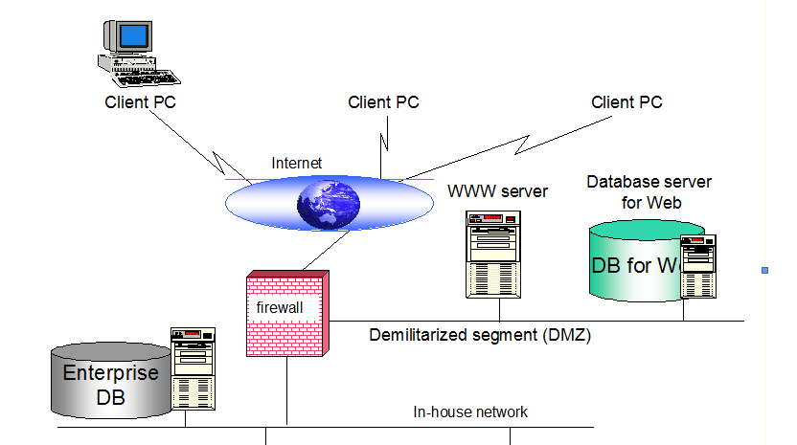
  2. Placement of Master tables

When databases (e.g., for order information) are divided into the enterprose database and Web database, they can be placed in divided or replicated style. For example, tables frequently referenced (e.g.,product master) can be copied from the enterprose database, and tables updated (e.g.,Order acceptance table) can be divided from the master and placed in the Web database.

In this case, attention must be paid for operation method so that, for example, stock quantity in a situation where orders via Web and telephone exist can be adjusted.

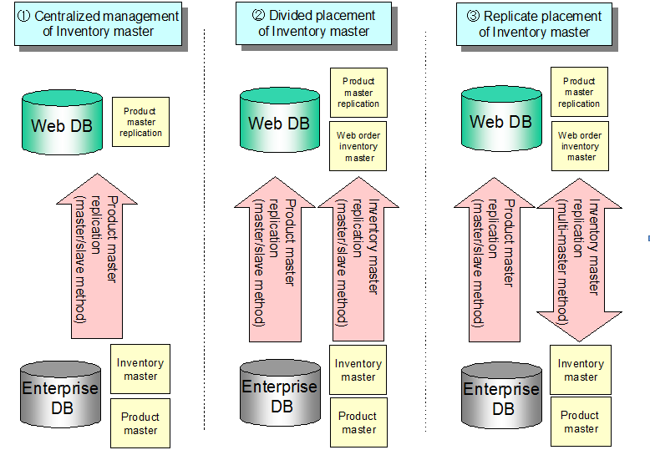

1. Centralized management of Inventory master

In this configuration, the Inventory master is placed in the enterprose database only, and not in the Web database. A mechanism for search and update the Inventory master in real-time, or consideration for reserving spare stock according to estimated quantity of order via Web is required. However, the former method requires SQL communication from the public server to the in-house network, and it is not recommended. The latter method has a risk of orders via Web exceeding the stock quantity. The following may resolve these problems.

- Inform the customer of estimated time required for shipment.

- Indicate the maximum time required for shipment if the item is out of stock.

1. Divided placement of Inventory master

In this configuration, the Inventory master is divided into Web and enterprise databases. In this case, however, an item can be out of stock in the Web database while it is still in stock in the enterprise database. To avoid this, always reflect the number of orders via Web on the enterprise database and adjust the stock quantity.

1. Replicate placement of Inventry master

In this configuration, the Inventory master is replicated between the Web server and enterprise server, in the multi-master method. In this case, since both databases are updated simultaneously, integrity must be maintained.

Refresh can be done synchronously or asynchronously.